MD2201: Data Science

Name of the student: Shrinivas Hatyalikar Roll No. 24

Div: B Batch: B1

Date of performance: 10/11/2022

Experiment No.4

Title: Regression .
Aim: i. To construct a simple linear regression model
ii. To construct a multiple linear regression model.

Software used: Programming language R.

Data Set: Toy Sales Dataset

Code Statement:
- Simple Linear Regression
- Consider the Toy sales data set.
- Apply simple linear model considering response as Unit sales and explanatory variable as Price.
- Plot the scatter plot and draw the regression.
- What are values of R-square and residual standard error? (Write in conclusion)
- Display all predicted values from the designed model and the corresponding values of error.
- Multiple Linear regression:
- Consider Toy sales data set.
- Consider all variables to fit the regression model.
- Compare the R-square of SLR with MLR. (Write in conclusion)
- Which of the variable is more significant? Why? (Write in conclusion)
- Can you reject Null hypothesis for promotion expenditure variable? (Write in conclusion)
- Which scenario from the following you will select to be applied to get maximum number of Unit sales? (Write in conclusion)
- Price=9.1$, Adexp=52,000$, Promexp=61,000$
- Price=8.1$, Adexp=50,000$,Promexp=60,000$

Code:

#Simple Linear Regression
f<-read.csv("Toy_store.csv")
l1<-lm(Unitsales~Price,f) #lm(y-variable~x-variable,filename)
s1<-summary(l1)
print(s1)

#Model => y = 114215.1 - 4913.7(price) {y=b0+b1x}
#plot Regression Line
library(ggplot2)
p<-ggplot(f,aes(Price,Unitsales))+geom_point()+geom_smooth(method=lm,formula=y~x,se=F,col="red")
print(p)

#printing predicted value
pred<-predict(l1)
print(pred)
e<-f$Unitsales-pred #Error = Actual-predicted
print(e)

#Multiple Regression
l2<-lm(Unitsales~Price+Adexp+Promexp,f) #lm(y-variable~x1+x2+...xn,filename)
s2<-summary(l2)
print(s2)

#Model => {y=B0+B1x1+B2x2+...BnXn}
#y=-250968 - 5055.3(price) + 648(Axemp) + 1802.6(Promexp)

df1<-data.frame(Price=c(9.1,8.1),Adexp=c(52,50),Promexp=c(61,60))
pred1<-predict(l2,df1)
s<-cbind(df1,pred1)
print(s)

Results: Display the output obtained on R console for all the cases.

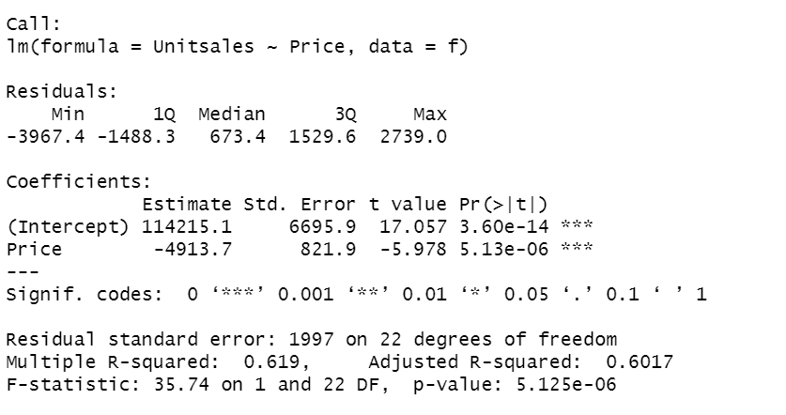

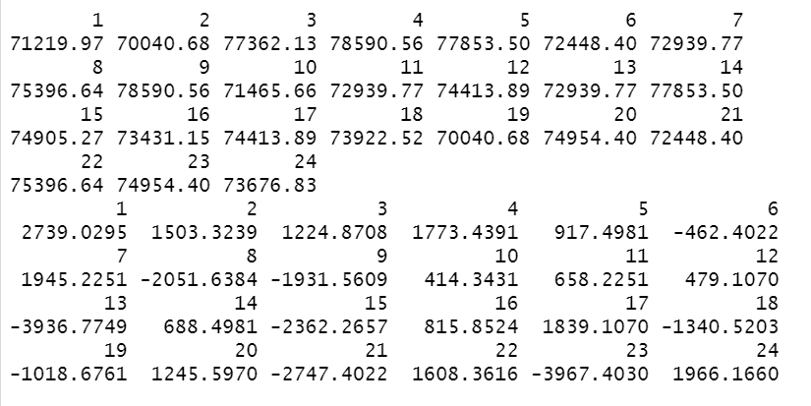

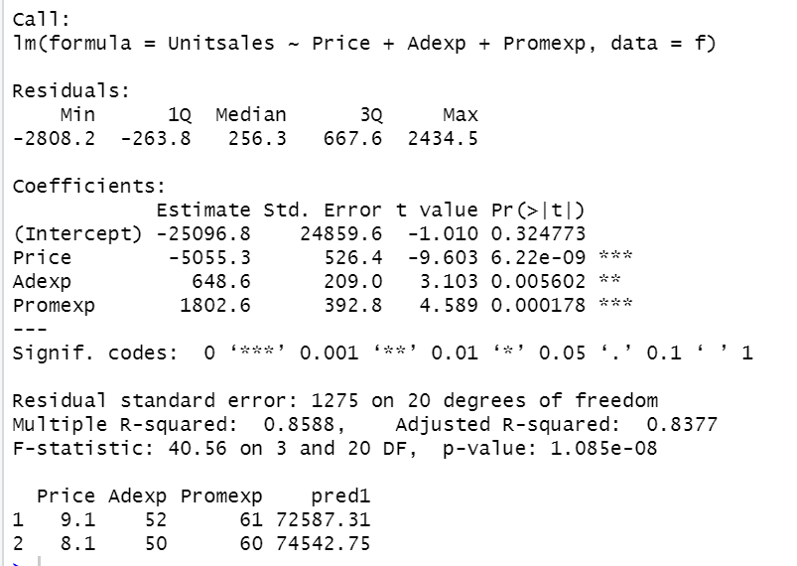

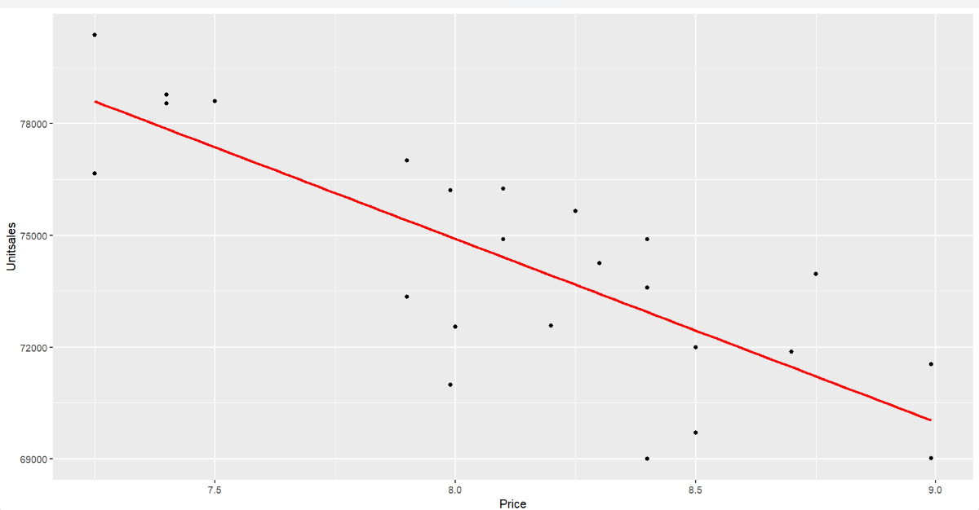

Conclusion:

The following experiment concludes the simple linear regression and multiple linear regression in R language .

1.4) Value of rse : 1997 , value of mse : 0.619

2.3) R -squared value of SLR: 0.6017

R -squared value of MLR:0.83777

2.4) The value of MLR is more significant than SLR because MLR is closer to one 1.

2.5)We cannot reject null hypothesis as the value of p (promo expenditure) is not more than 0.05 , thus the null hypothesis needs to be accepted.

2.6) Since the predicted sales for case 2 are more, the second scenario is more favorable to the toy selling company.

